**Digital Nurture 4.0 Deep Skilling - Java FSE**

**Week-3(Mandatory HandsOn)**

**Spring Data JPA with Spring Boot, Hibernate**

**Exercise 1 Spring Data JPA - Quick Example**

**Program**

**pom.xml**  
<?xml version="1.0" encoding="UTF-8"?>

<project xmlns="http://maven.apache.org/POM/4.0.0"

xmlns:xsi="http://www.w3.org/2001/XMLSchema-instance"

xsi:schemaLocation="http://maven.apache.org/POM/4.0.0 https://maven.apache.org/xsd/maven-4.0.0.xsd">

<modelVersion>4.0.0</modelVersion>

<parent>

<groupId>org.springframework.boot</groupId>

<artifactId>spring-boot-starter-parent</artifactId>

<version>3.5.3</version>

<relativePath/> <!-- lookup parent from repository -->

</parent>

<groupId>com.example</groupId>

<artifactId>ormlearn</artifactId>

<version>0.0.1-SNAPSHOT</version>

<name>ormlearn</name>

<description>Demo project for Spring Boot</description>

<properties>

<java.version>17</java.version>

</properties>

<dependencies>

<dependency>

<groupId>org.springframework.boot</groupId>

<artifactId>spring-boot-starter-data-jpa</artifactId>

</dependency>

<dependency>

<groupId>com.mysql</groupId>

<artifactId>mysql-connector-j</artifactId>

<version>8.0.33</version>

<scope>runtime</scope>

</dependency>

<dependency>

<groupId>org.springframework.boot</groupId>

<artifactId>spring-boot-devtools</artifactId>

<scope>runtime</scope>

<optional>true</optional>

</dependency>

<dependency>

<groupId>org.springframework.boot</groupId>

<artifactId>spring-boot-starter-test</artifactId>

<scope>test</scope>

</dependency>

</dependencies>

<build>

<plugins>

<plugin>

<groupId>org.springframework.boot</groupId>

<artifactId>spring-boot-maven-plugin</artifactId>

</plugin>

</plugins>

</build>

</project>

**application.properties**

spring.application.name=ormlearn

# Logging

logging.level.org.springframework=info

logging.level.com.example.ormlearn=debug

logging.level.org.hibernate.SQL=debug

logging.level.org.hibernate.type.descriptor.sql=trace

# Database

spring.datasource.driver-class-name=com.mysql.cj.jdbc.Driver

spring.datasource.url=jdbc:mysql://localhost:3306/ormlearn

spring.datasource.username=root

spring.datasource.password=Shri19

# Hibernate

spring.jpa.hibernate.ddl-auto=validate

spring.jpa.properties.hibernate.dialect=org.hibernate.dialect.MySQLDialect

**Country.java**

package com.example.ormlearn.model;

import jakarta.persistence.Entity;

import jakarta.persistence.Id;

import jakarta.persistence.Table;

import jakarta.persistence.Column;

@Entity

@Table(name = "country")

public class Country {

@Id

@Column(name = "co_code")

private String code;

@Column(name = "co_name")

private String name;

public String getCode() {

return code; }

public void setCode(String code) {

this.code = code;}

public String getName() {

return name;}

public void setName(String name) {

this.name = name;}

@Override

public String toString() {

return "Country [code=" + code + ", name=" + name + "]";}}

**CountryRepository.java**

package com.example.ormlearn.repository;

import org.springframework.data.jpa.repository.JpaRepository;

import org.springframework.stereotype.Repository;

import com.example.ormlearn.model.Country;

@Repository

public interface CountryRepository extends JpaRepository<Country, String> {}

**CountryService.java**

package com.example.ormlearn.service;

import java.util.List;

import jakarta.transaction.Transactional;

import org.springframework.beans.factory.annotation.Autowired;

import org.springframework.stereotype.Service;

import com.example.ormlearn.model.Country;

import com.example.ormlearn.repository.CountryRepository;

@Service

public class CountryService {

@Autowired

private CountryRepository countryRepository;

@Transactional

public List<Country> getAllCountries() {

return countryRepository.findAll();

}}

**OrmlearnApllication.java**

package com.example.ormlearn;

import java.util.List;

import org.slf4j.Logger;

import org.slf4j.LoggerFactory;

import org.springframework.boot.SpringApplication;

import org.springframework.boot.autoconfigure.SpringBootApplication;

import org.springframework.context.ApplicationContext;

import com.example.ormlearn.model.Country;

import com.example.ormlearn.service.CountryService;

@SpringBootApplication

public class OrmlearnApplication {

private static final Logger LOGGER =

LoggerFactory.getLogger(OrmlearnApplication.class);

private static CountryService countryService;

public static void main(String[] args) {

ApplicationContext context = SpringApplication.run(OrmlearnApplication.class, args);

countryService = context.getBean(CountryService.class);

LOGGER.info("Inside main");

testGetAllCountries();

}

private static void testGetAllCountries() {

LOGGER.info("Start");

List<Country> countries = countryService.getAllCountries();

LOGGER.debug("countries={}", countries);

LOGGER.info("End");

}}

**Output:**

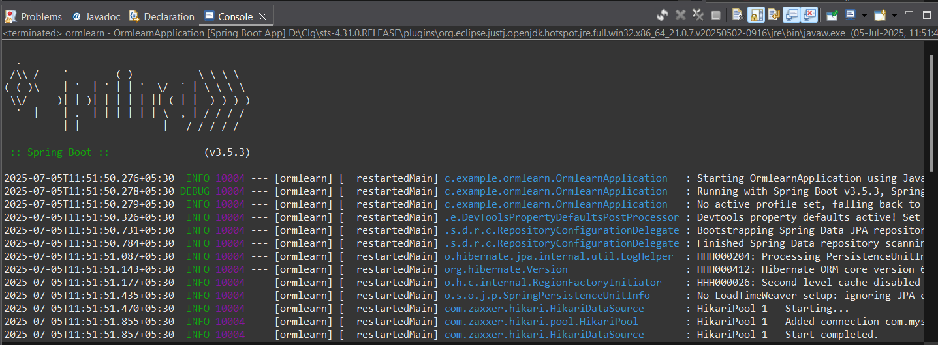

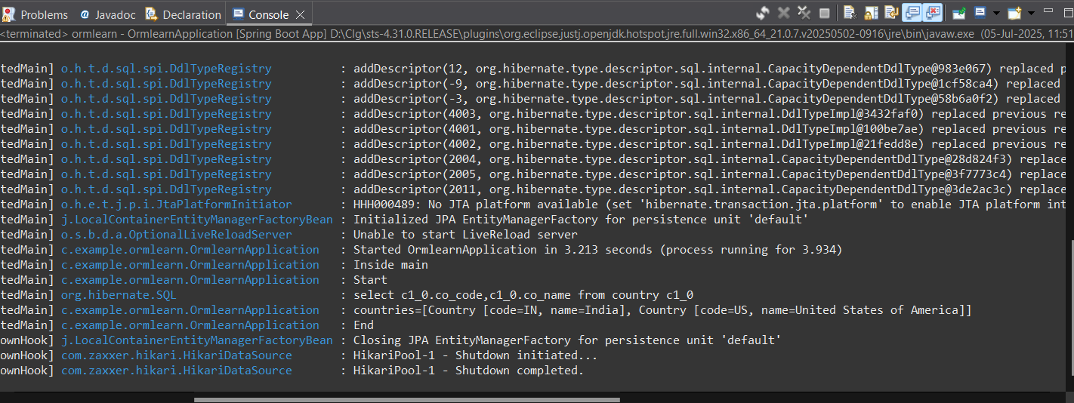

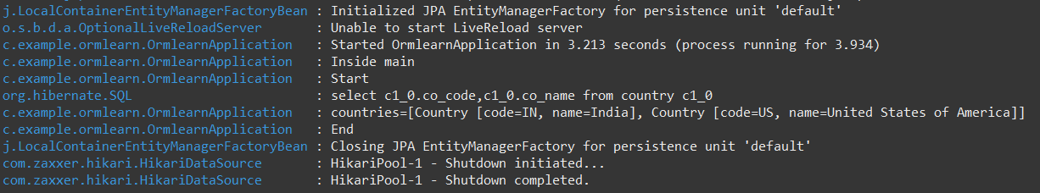

**Exercise 4 : Difference between JPA, Hibernate and Spring Data JPA**

**pom.xml**  
<project xmlns="http://maven.apache.org/POM/4.0.0"

xmlns:xsi="http://www.w3.org/2001/XMLSchema-instance"

xsi:schemaLocation="

http://maven.apache.org/POM/4.0.0

http://maven.apache.org/xsd/maven-4.0.0.xsd">

<modelVersion>4.0.0</modelVersion>

<groupId>com.example</groupId>

<artifactId>jpa-hibernate-employee</artifactId>

<version>0.0.1-SNAPSHOT</version>

<packaging>jar</packaging>

<name>jpa-hibernate-employee</name>

<description>Spring Boot app using Spring Data JPA and MySQL</description>

<parent>

<groupId>org.springframework.boot</groupId>

<artifactId>spring-boot-starter-parent</artifactId>

<version>3.2.4</version> <!-- You can update to latest -->

<relativePath/> <!-- lookup parent from repository -->

</parent>

<properties>

<java.version>17</java.version>

</properties>

<dependencies>

<dependency>

<groupId>org.springframework.boot</groupId>

<artifactId>spring-boot-starter-web</artifactId>

</dependency>

<dependency>

<groupId>org.springframework.boot</groupId>

<artifactId>spring-boot-starter-data-jpa</artifactId>

</dependency>

<dependency>

<groupId>com.mysql</groupId>

<artifactId>mysql-connector-j</artifactId>

<scope>runtime</scope>

</dependency>

<dependency>

<groupId>org.projectlombok</groupId>

<artifactId>lombok</artifactId>

<optional>true</optional>

</dependency>

<dependency>

<groupId>org.springframework.boot</groupId>

<artifactId>spring-boot-devtools</artifactId>

<scope>runtime</scope>

</dependency>

<dependency>

<groupId>org.springframework.boot</groupId>

<artifactId>spring-boot-starter-test</artifactId>

<scope>test</scope>

</dependency>

</dependencies>

<build>

<plugins>

<plugin>

<groupId>org.apache.maven.plugins</groupId>

<artifactId>maven-compiler-plugin</artifactId>

<version>3.11.0</version>

<configuration>

<source>17</source>

<target>17</target>

</configuration>

</plugin>

</plugins>

</build>

</project>

**application.properties**

spring.application.name=jpahibernateemployee

# MySQL Configuration

spring.datasource.url=jdbc:mysql://localhost:3306/test_db

spring.datasource.username=root

spring.datasource.password=Shri19

# JPA Properties

spring.jpa.hibernate.ddl-auto=update

spring.jpa.show-sql=true

spring.jpa.properties.hibernate.dialect=org.hibernate.dialect.MySQL8Dialect

**Employee.java**

package com.example.employee.model;

import jakarta.persistence.Entity;

import jakarta.persistence.Id;

@Entity

public class Employee {

@Id

private int id;

private String name;

private String department;

public int getId() {

return id;

}

public void setId(int id) {

this.id = id;

}

public String getName() {

return name;

}

public void setName(String name) {

this.name = name;

}

public String getDepartment() {

return department;

}

public void setDepartment(String department) {

this.department = department;

}

}

**EmployeeRepository.java**

package com.example.employee.repository;

import org.springframework.data.jpa.repository.JpaRepository;

import com.example.employee.model.Employee;

public interface EmployeeRepository extends JpaRepository<Employee, Integer> {

}

**EmployeeService.java**

package com.example.employee.service;

import org.springframework.beans.factory.annotation.Autowired;

import org.springframework.stereotype.Service;

import org.springframework.transaction.annotation.Transactional;

import com.example.employee.model.Employee;

import com.example.employee.repository.EmployeeRepository;

@Service

public class EmployeeService {

@Autowired

private EmployeeRepository employeeRepository;

@Transactional

public void addEmployee(Employee employee) {

employeeRepository.save(employee);

}

}

**JpahibernateemployeeApllication.java**

package com.example.employee;

import org.springframework.beans.factory.annotation.Autowired;

import org.springframework.boot.CommandLineRunner;

import org.springframework.boot.SpringApplication;

import org.springframework.boot.autoconfigure.SpringBootApplication;

import com.example.employee.model.Employee;

import com.example.employee.service.EmployeeService;

@SpringBootApplication

public class JpahibernateemployeeApplication implements CommandLineRunner {

@Autowired

private EmployeeService employeeService;

public static void main(String[] args) {

SpringApplication.run(JpahibernateemployeeApplication.class, args);

}

@Override

public void run(String... args) throws Exception {

Employee emp = new Employee();

emp.setId(101);

emp.setName("John");

emp.setDepartment("IT");

employeeService.addEmployee(emp);

}

}

**Output:**

